**LAB-3**

**Design a star topology using both hub and switch**

**in packet tracer.**

**Simulating Star Topology**

Star topology is one of the most common network setups. Every node connects to a central network device in this configuration, like a hub, switch, or computer. The central network device acts as a server, and the peripheral devices act as clients. In a star topology setup, either a coaxial or RJ-45 network cable is used, depending on each computer's type of network card. The image shows how this network setup gets its name, as it is shaped like a star. There technically is no limit to how many computers can connect in a star topology. However, network performance can decrease as more computers are connected, resulting in slower network speeds.

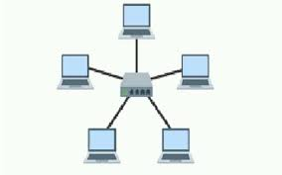

**Process on Setting up a network in Cisco Packet Tracer**

**Step 1:** Select a central network device and any type of end-devices. I have chosen a switch and four PC.

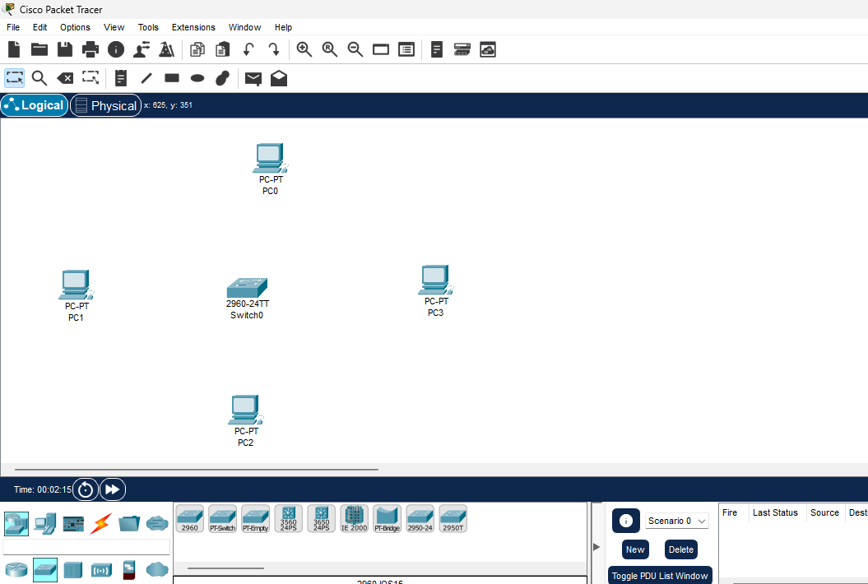

**Step 2:** Link every device with the switch.

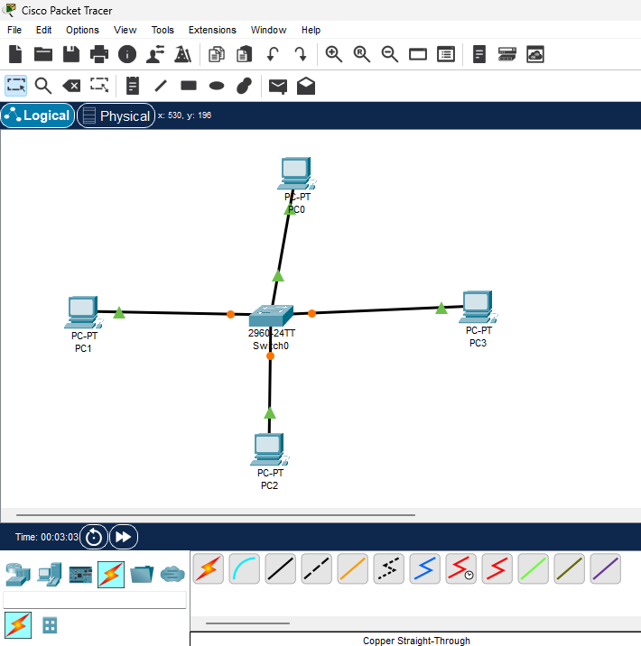

**Step 3:** Provide the IP Address to every device.

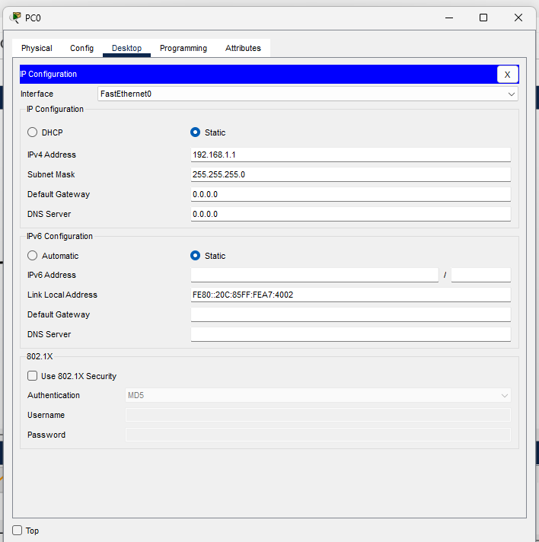

**Step 4:** Check whether the connections are correct. I am trying to ping PC1 from PC4.

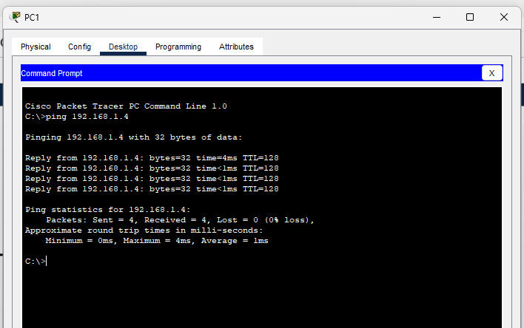

**Step 5:** Transfer message from one device to another. Here I am trying to transfer message from PC0 to PC2. Firstly, the packet is generated at “PC0” then the packet is sent to switch.

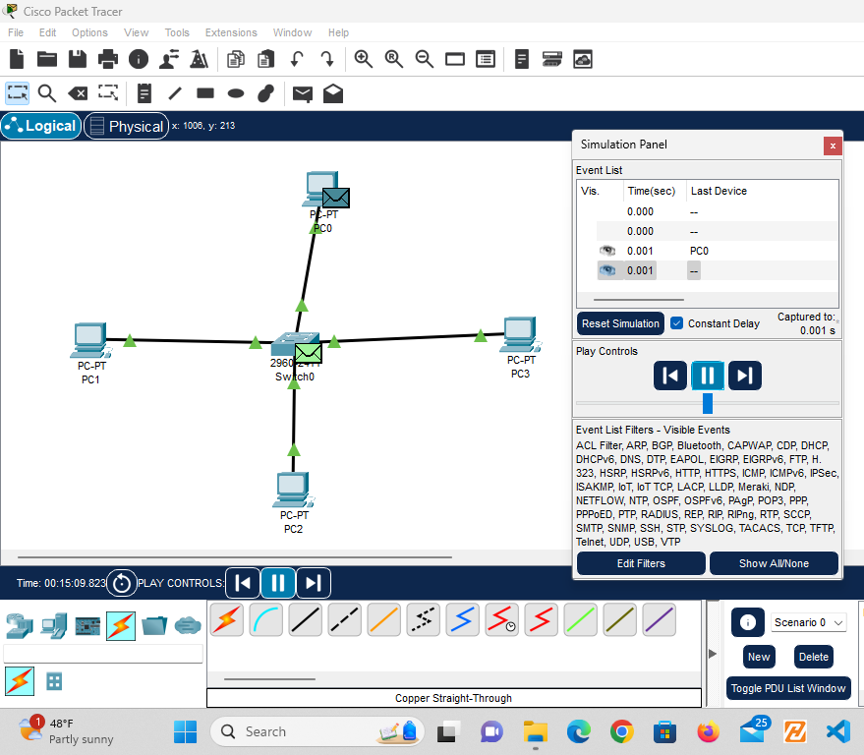

Then, the switch sends the packet to the receiver (i.e. PC2).

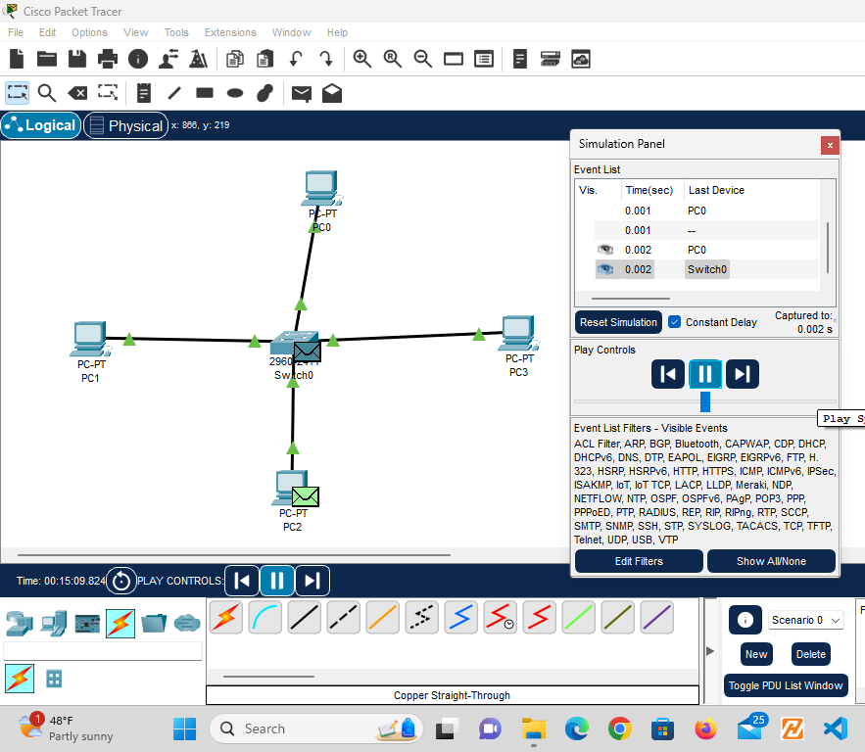

After the receiver receives the message, the receiver sends the acknowledgement message to the switch and then the switch sends the acknowledgment message to the sender.

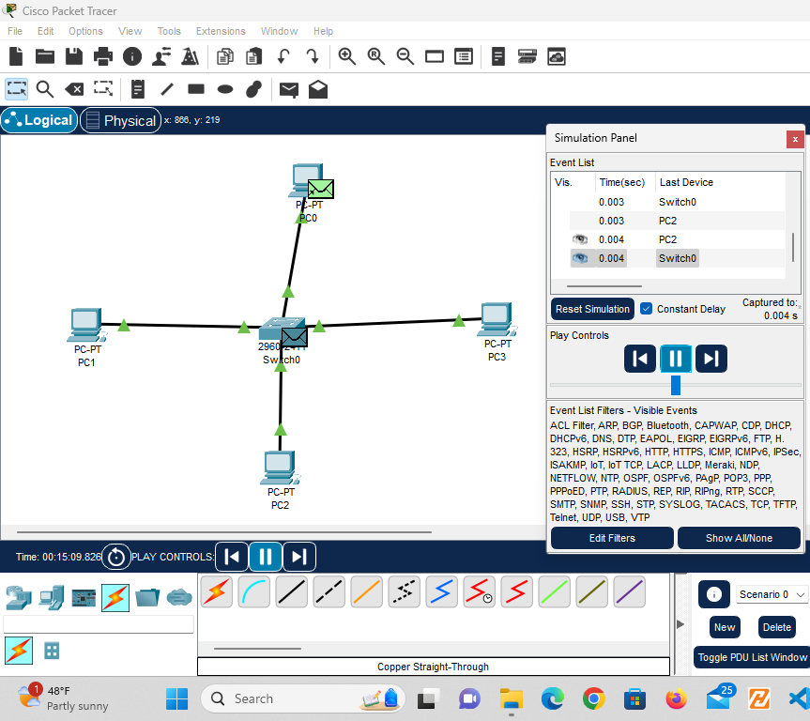

**Star topology using hub as a central device:**

**Step1:** Select a central network device and any type of end-devices. I have chosen a hub and eight PC. Connect each end device to central network device.

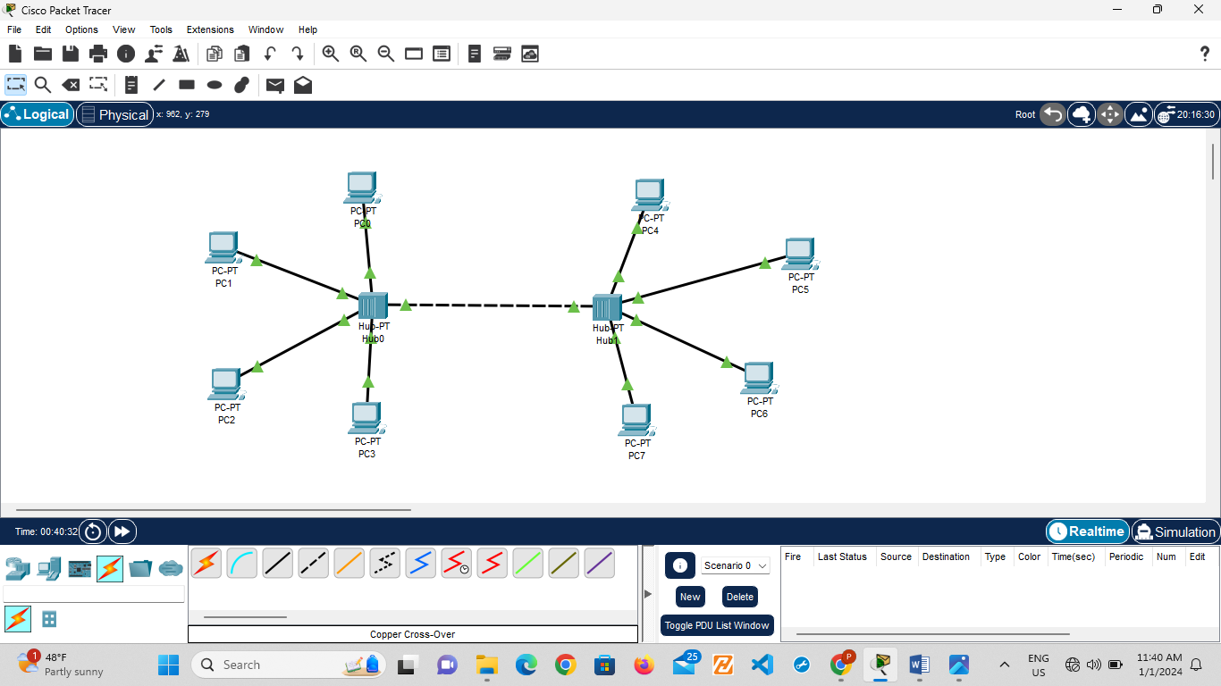

**Step 2:** Configure the IP address of each device.

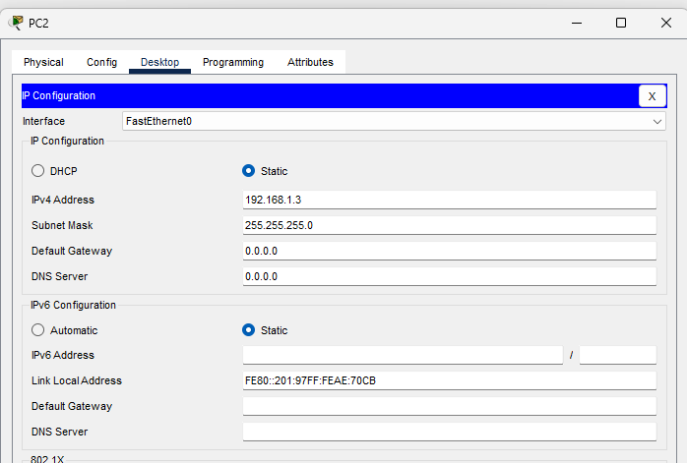

**Step 3:** Check whether the connections are correct. Here I am trying to ping “PC5” from “PC0”.

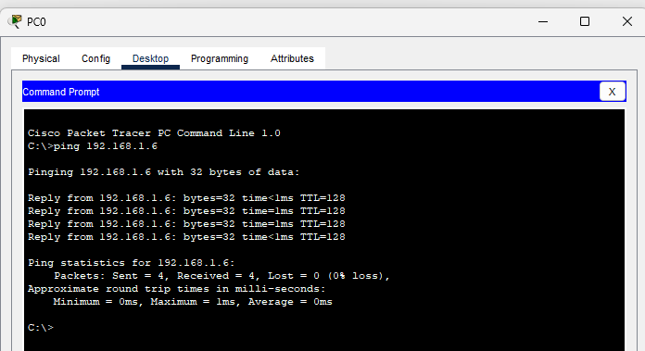

**Step 4:** Transfer message from one device to another. Here I am trying to transfer packet from “PC1” to “PC6”.

First a packet is generated at “PC0”. The packet is then sent to the immediate hub i.e. “Hub0”.

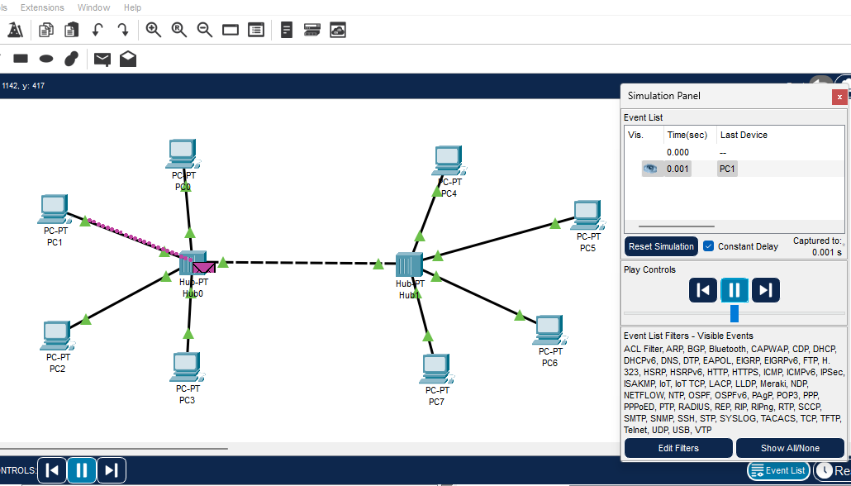

**Step 5:** Then “Hub0” sends the packet to all other immediate network devices including “Hub1”. If other devices are not the receiving devices, then the packet is rejected.

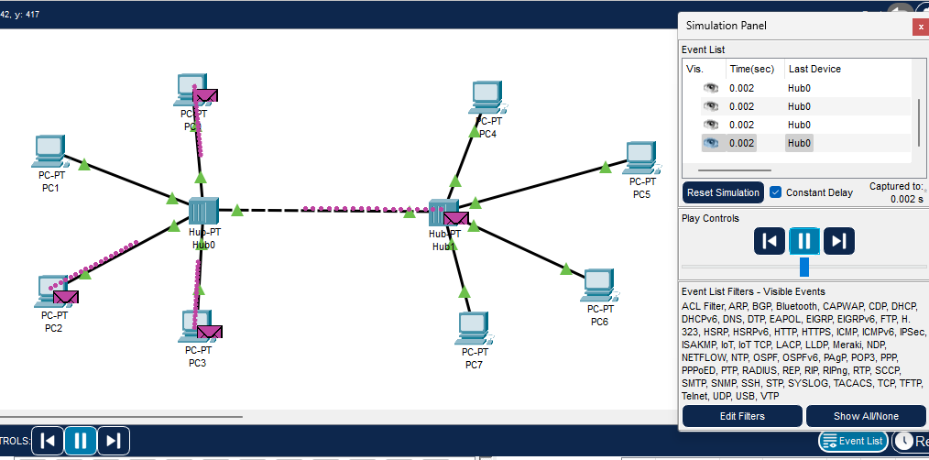

**Step 6:** Then “Hub1” sends the packet to all its immediate end devices. End devices other than the intended recipient rejects the packet.

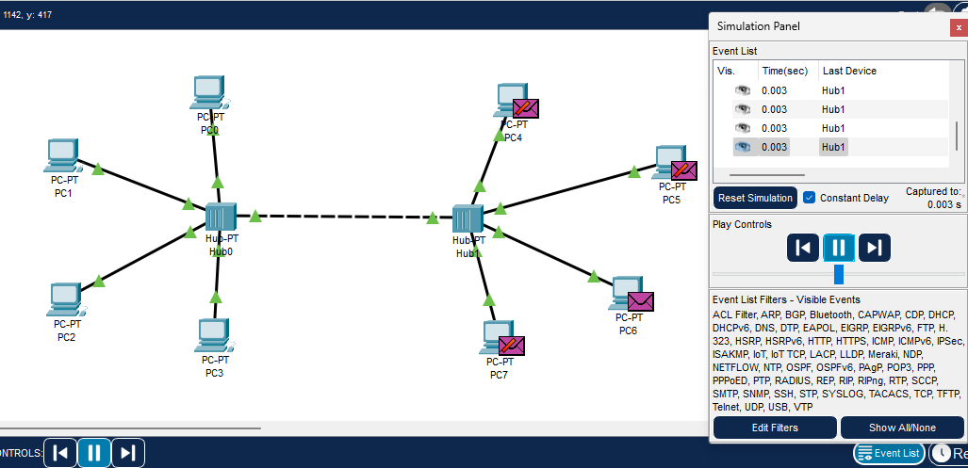

**Step 7:** The recipient then sends acknowledgement message to its immediate hub i.e. “Hub1”.

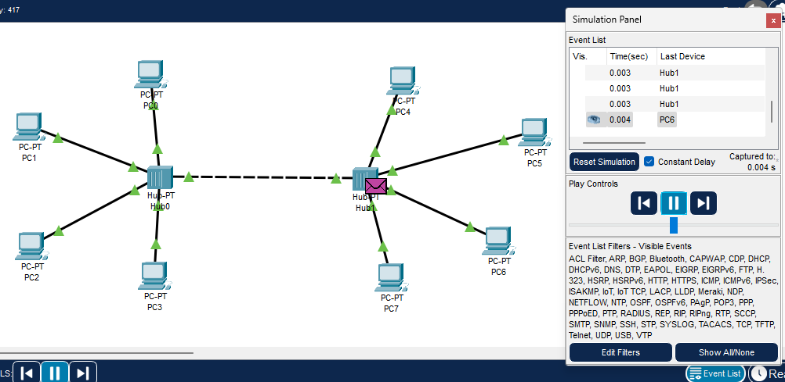

**Step 8:** Since the end devices in second network are not the sender they reject the acknowledgement message. The immediate hub i.e. “Hub1” sends the acknowledge message to “Hub0”.

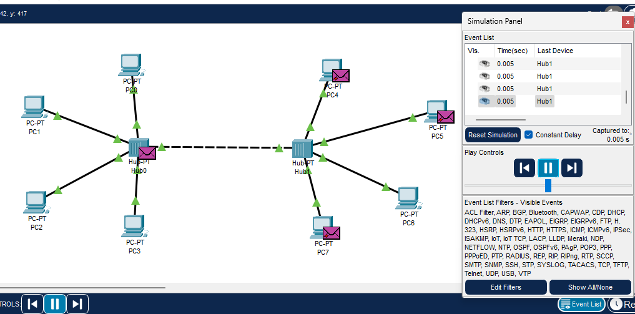

**Step 9:** Lastly, the acknowledge message is sent to the sender and other devices reject the acknowledge message.

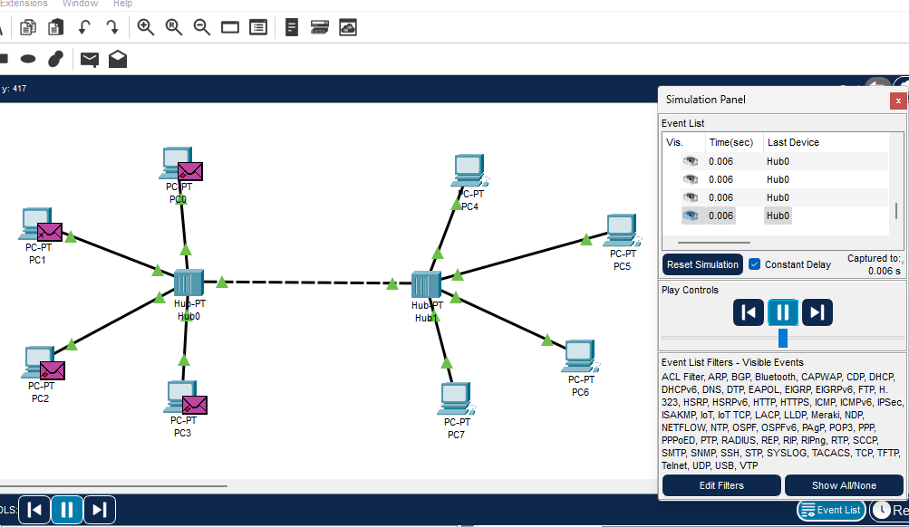

**Write a paragraph on difference between Hub and Switch relating the above simulation scenario.**

In Cisco Packet Tracer, hubs and switches are both networking devices, but they serve distinct purposes and exhibit significant differences in their functionalities. A hub operates at the physical layer of the OSI model and simply broadcasts incoming data to all connected devices within the network, regardless of the destination. This indiscriminate broadcasting can lead to network congestion and reduced efficiency, especially in larger networks. On the other hand, a switch operates at the data link layer and makes intelligent forwarding decisions based on MAC addresses. Unlike hubs, switches selectively forward data only to the specific device for which it is intended, improving overall network performance by minimizing unnecessary traffic. In essence, while a hub is a basic and passive device, a switch adds a layer of intelligence and efficiency to the network by facilitating targeted data transmission.

**Conclusion:**

Thus, We used Switch and Hub for setting up a network and found out that hub broadcast the data to all the connected devices whereas switch only broadcast the data to intended device.